**SWE645-EXTRA CREDIT**

**Charishma(G01478203), Nikhil(G01522509),**

**Vishnu(G01512364), Rohan(G01520778)**

**External IP**: <http://35.226.48.185/api/surveys>

**SPRING BOOT PROJECT FOR MICROSERVICES:**

1. Build a python project from scratch.
2. Implemented the CRUD logic. Below is the code of our project.

**main.py**

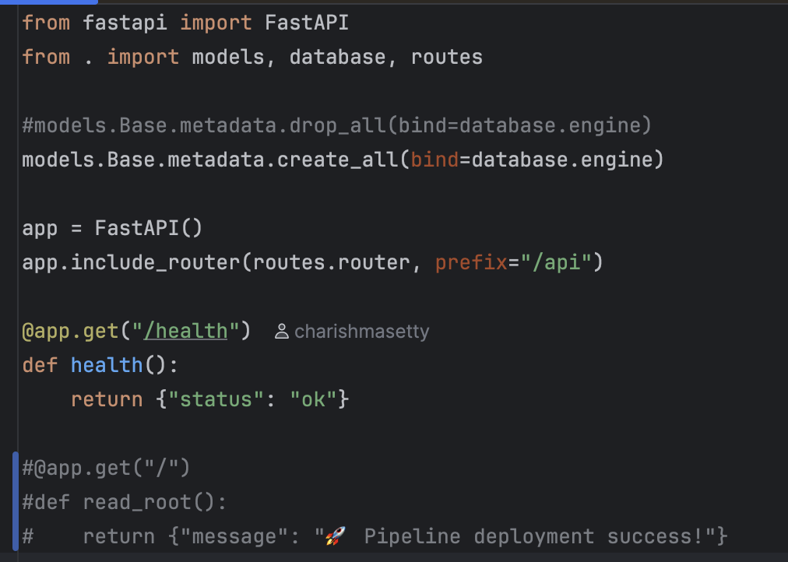

**models.py**

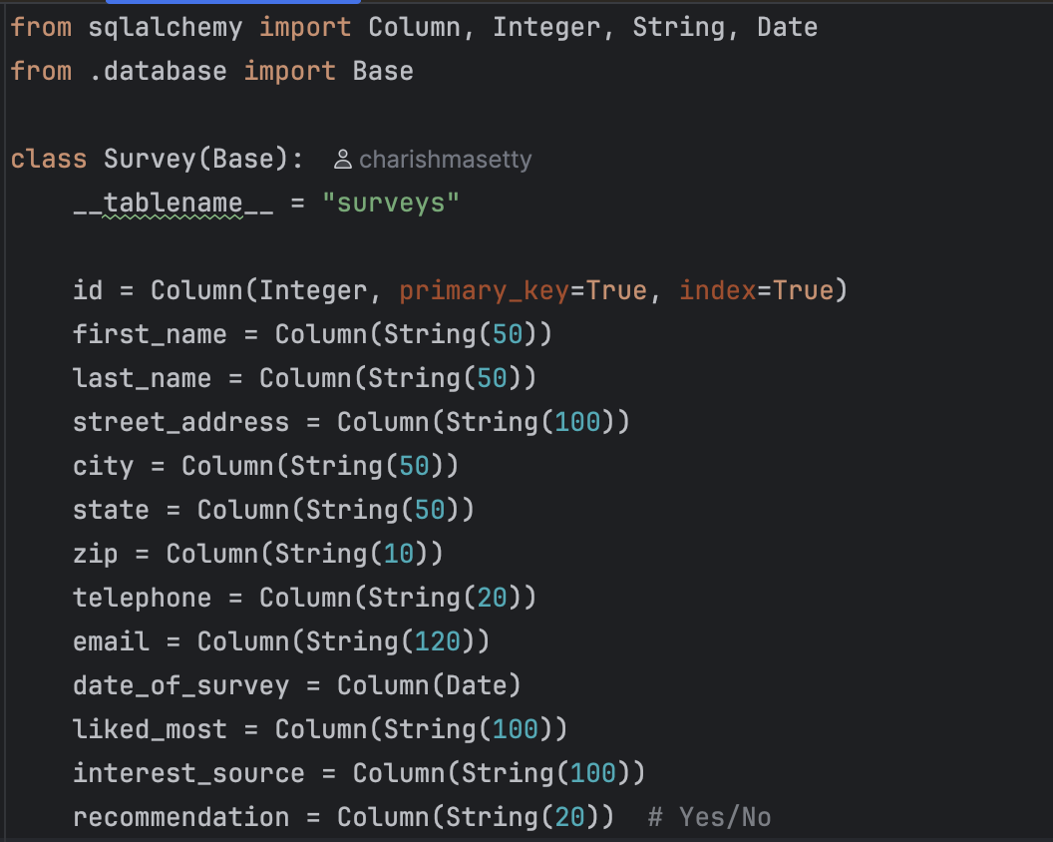

**routes.py**

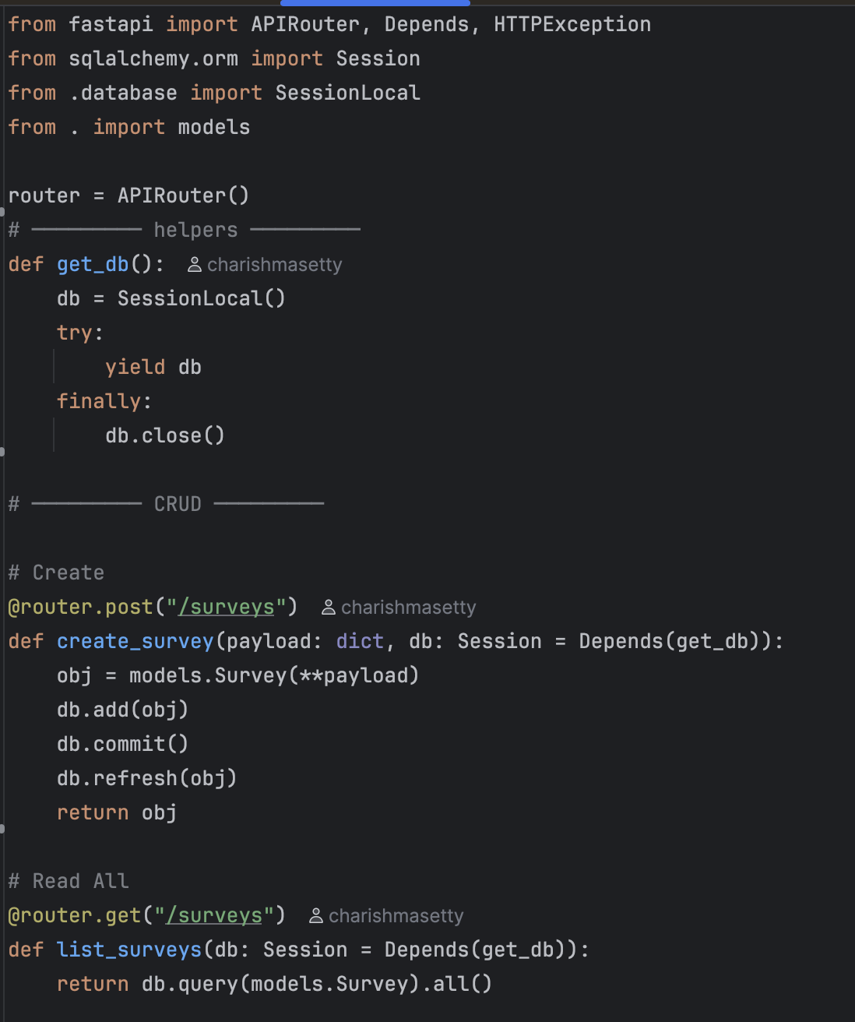

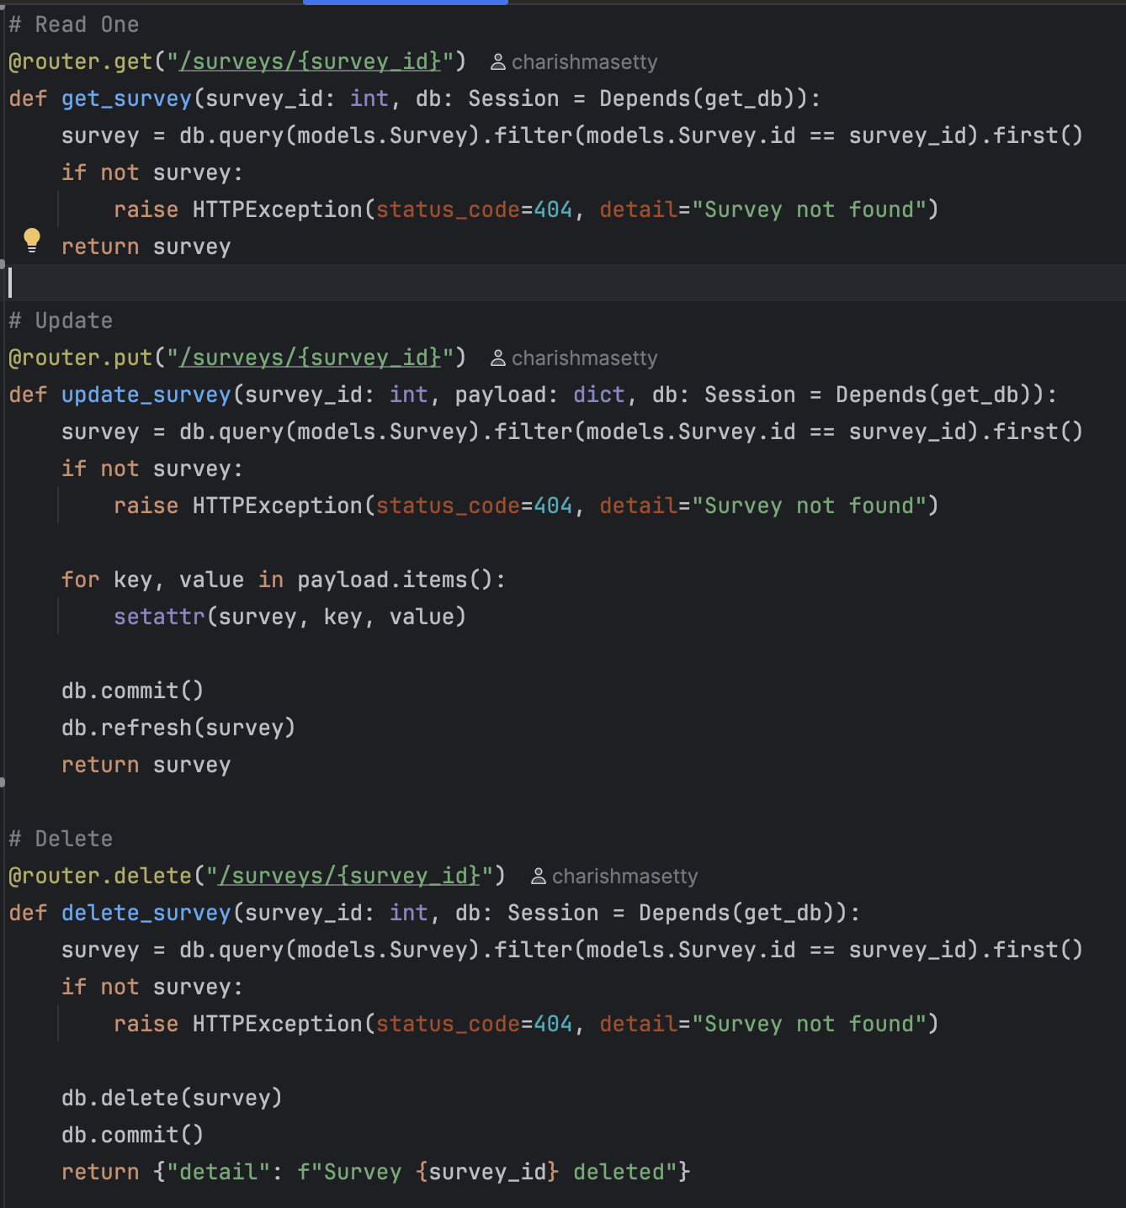

**run.py**

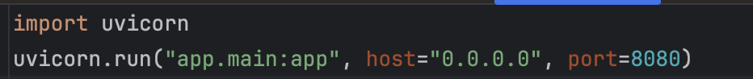

**__init__.py**

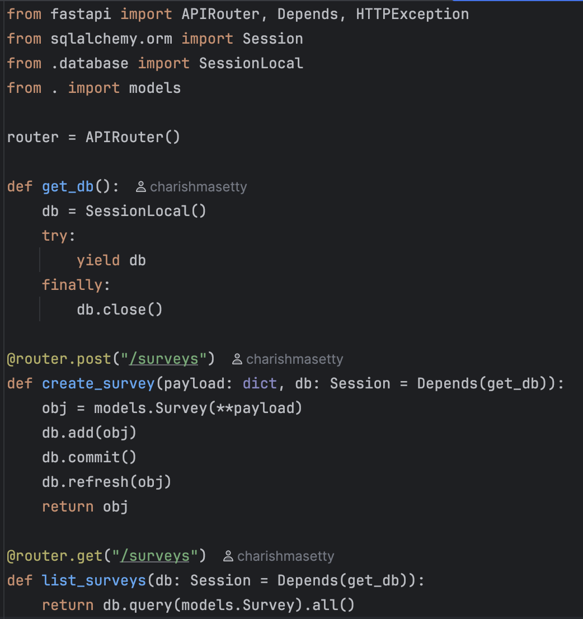

**database.py**

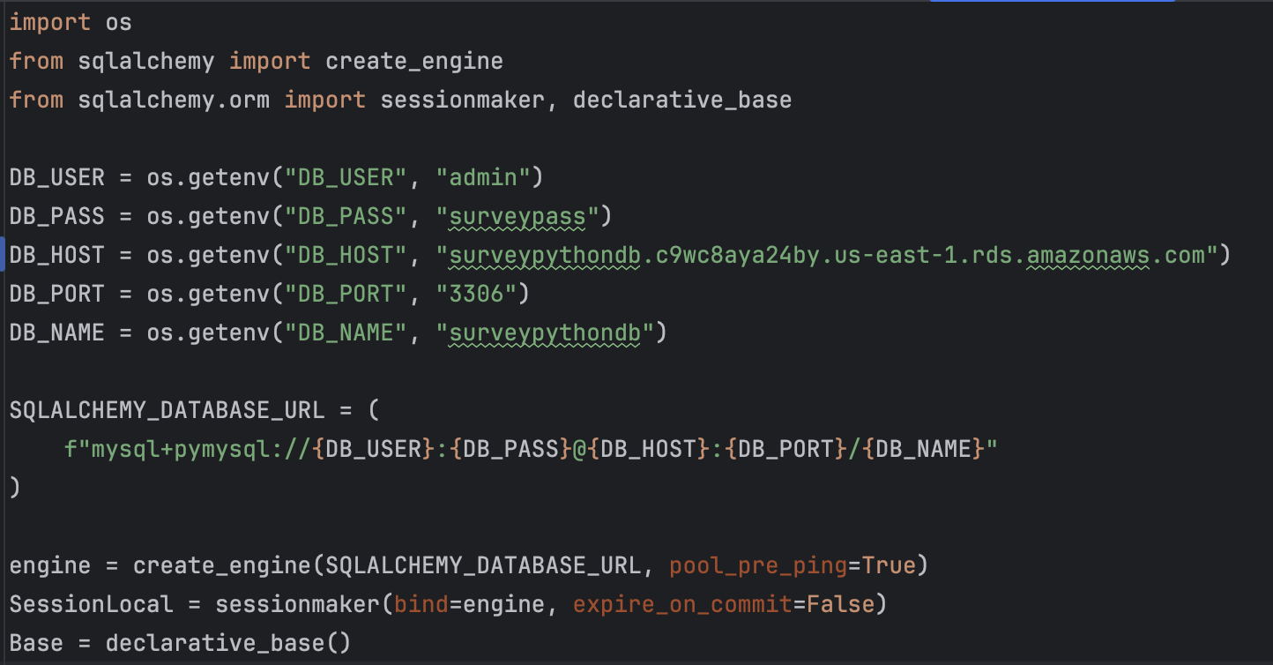

1. Built our project : Built the Python project using the following command.

**Command: source .venv/bin/activate**

**python run.py**

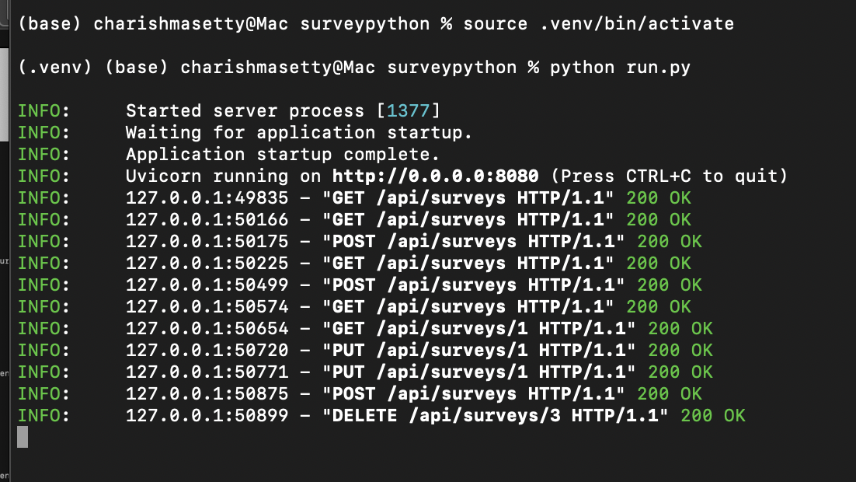

1. The URL to access the project on local: <http://localhost:8080/api/surveys>

(Below are the screenshots demonstrating CRUD operations in POSTMAN)

**VERIFYING ON POSTMAN IF ALL THE CRUD OPERATIONS ARE FUNCTIONING**

1. **POST**: To create a new survey entry.

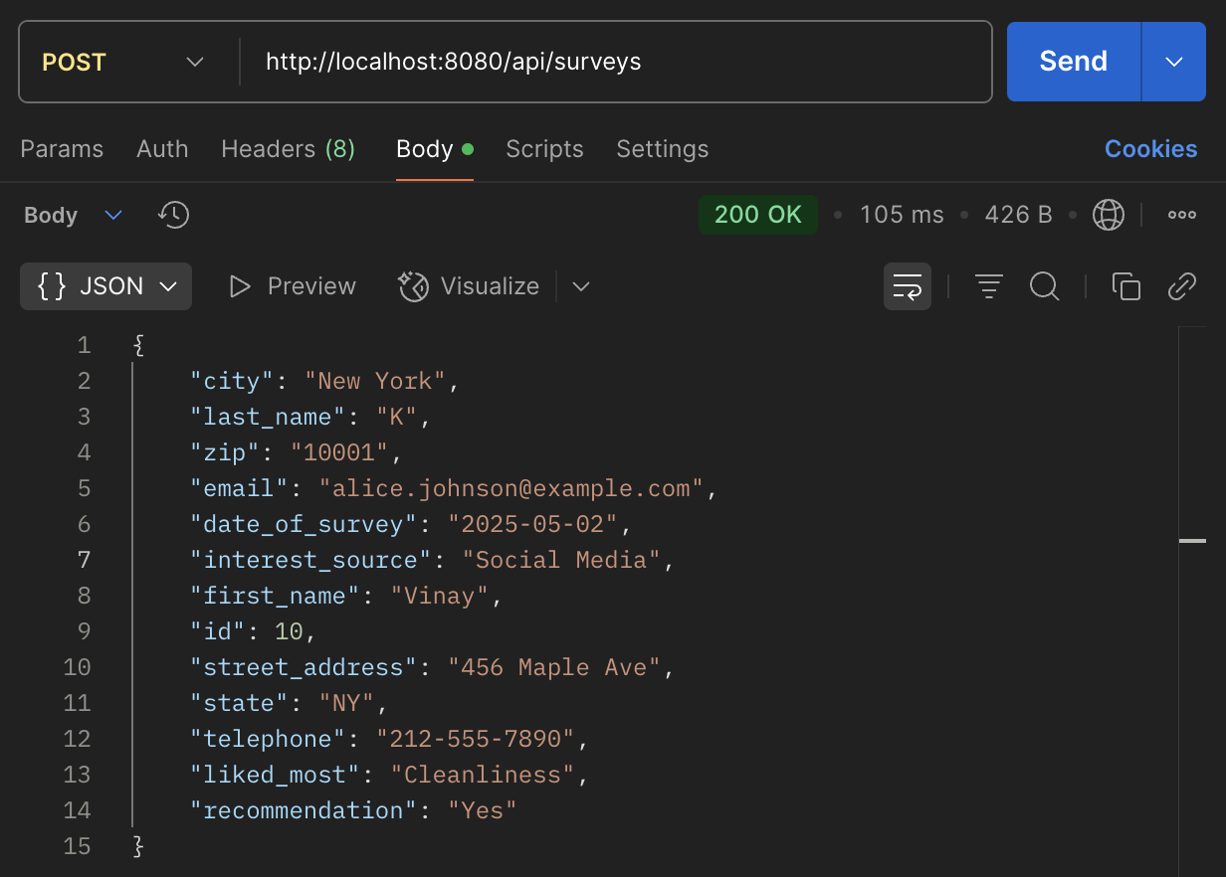

1. **GET**: To get all survey records.

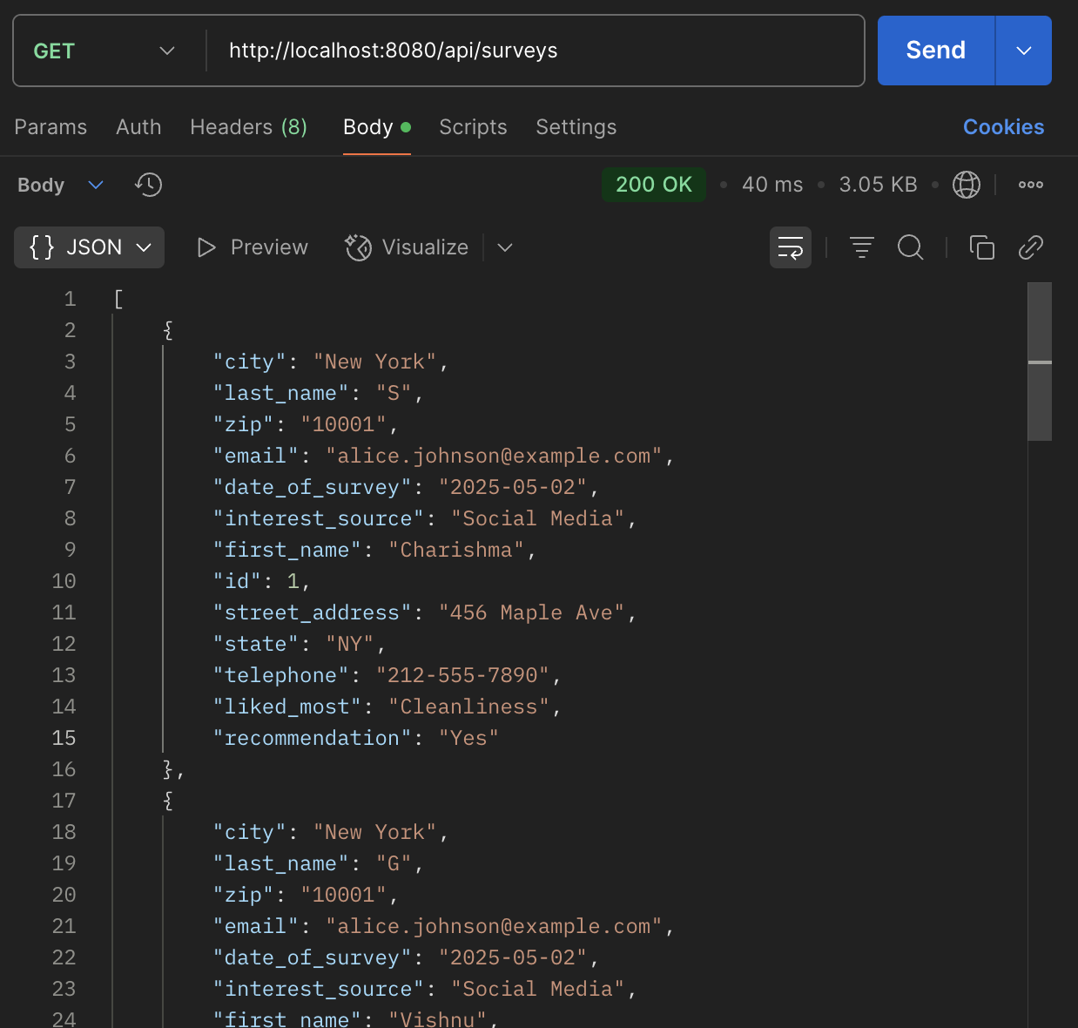

1. **GET BY ID**: To retrieve one record using the ID.

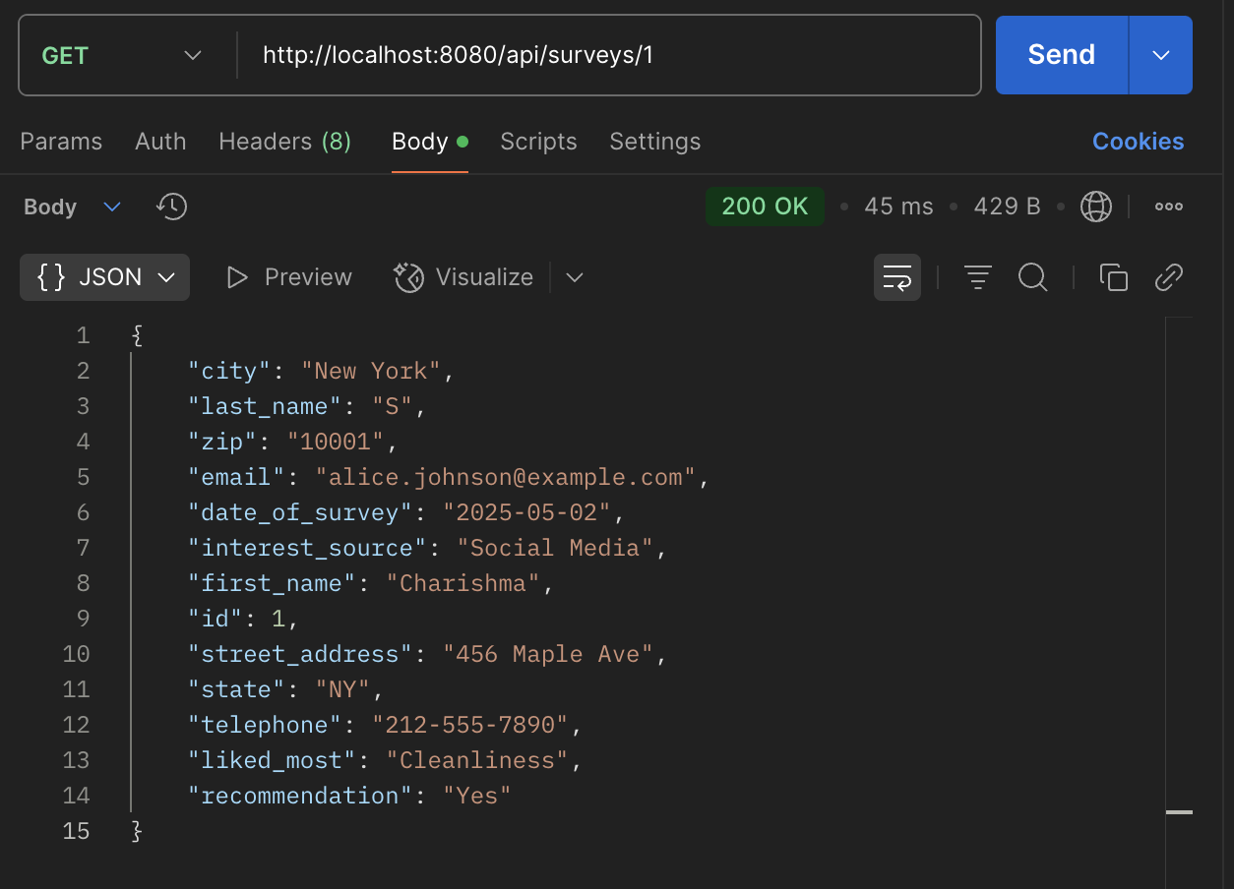

1. **PUT BY ID**: Update any survey record using the ID.

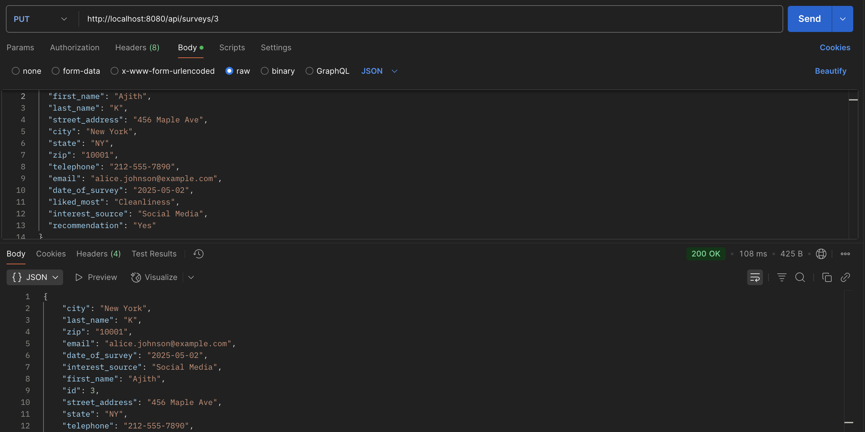

1. **DELETE**: Delete a survey record using the ID. And checking by trying to retrieve that ID.

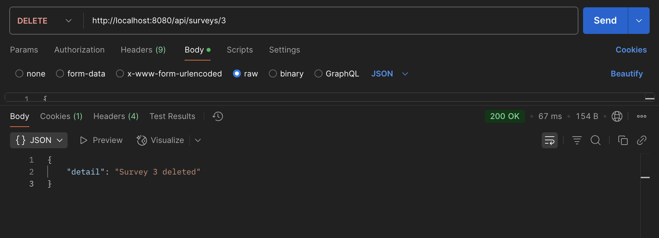

**BUILDING A DOCKER IMAGE OF OUR SPRING PROJECT:**

1. Create a Dockerfile in project root folder. This Dockerfile will give all the requirements to build the docker image.

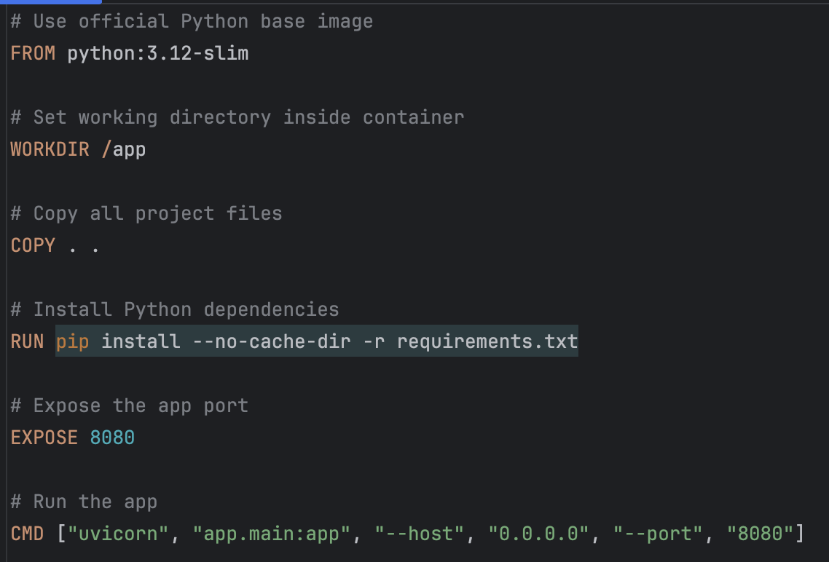

1. Containerize the python project, using Docker container technology.
2. **Build the Docker Image:** Using the following command to build our image.

**Command: docker build -t surveypython-app .**

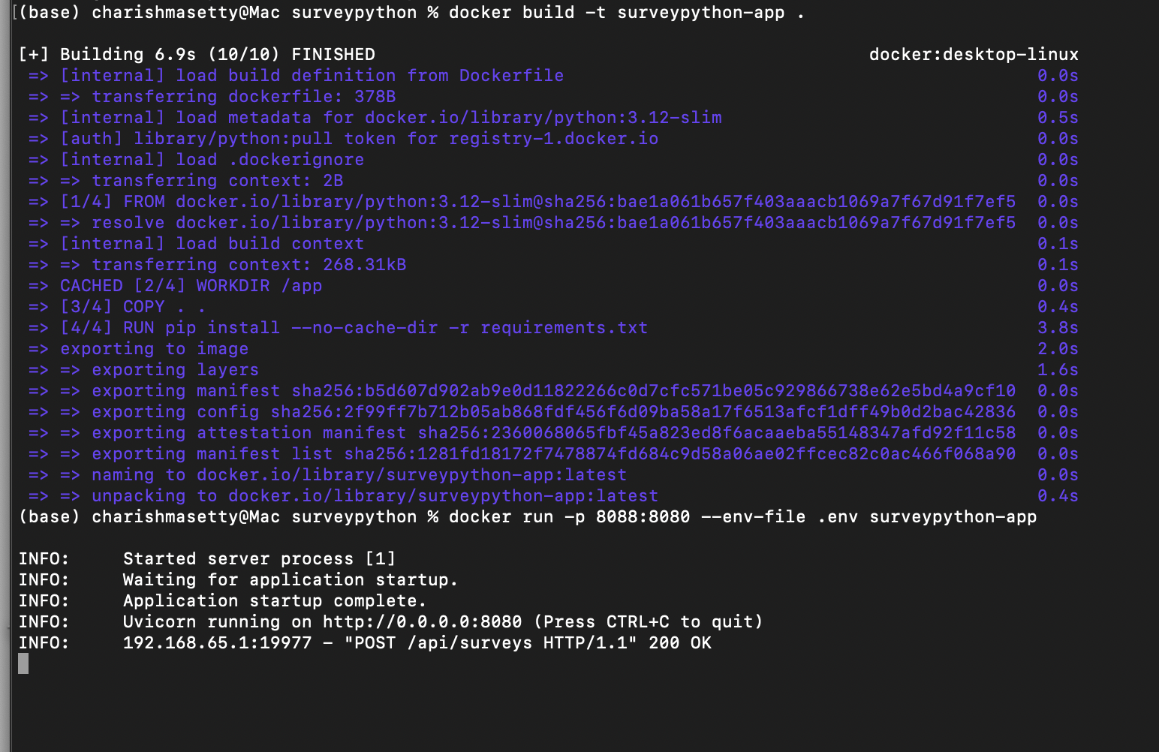

1. **Run the Docker Container on port 8088:** Now use the command and run the docker container named my container on port 8088.

**Command: docker run -p 8088:8080 --env-file .env surveypython-app**



1. The URL to access the docker image: <http://localhost:8088/api/surveys>

**VERIFYING ON POSTMAN IF IMAGE BUILD AND THE CRUD OPERATIONS ARE FUNCTIONING**

1. **GET**: To get all survey records.

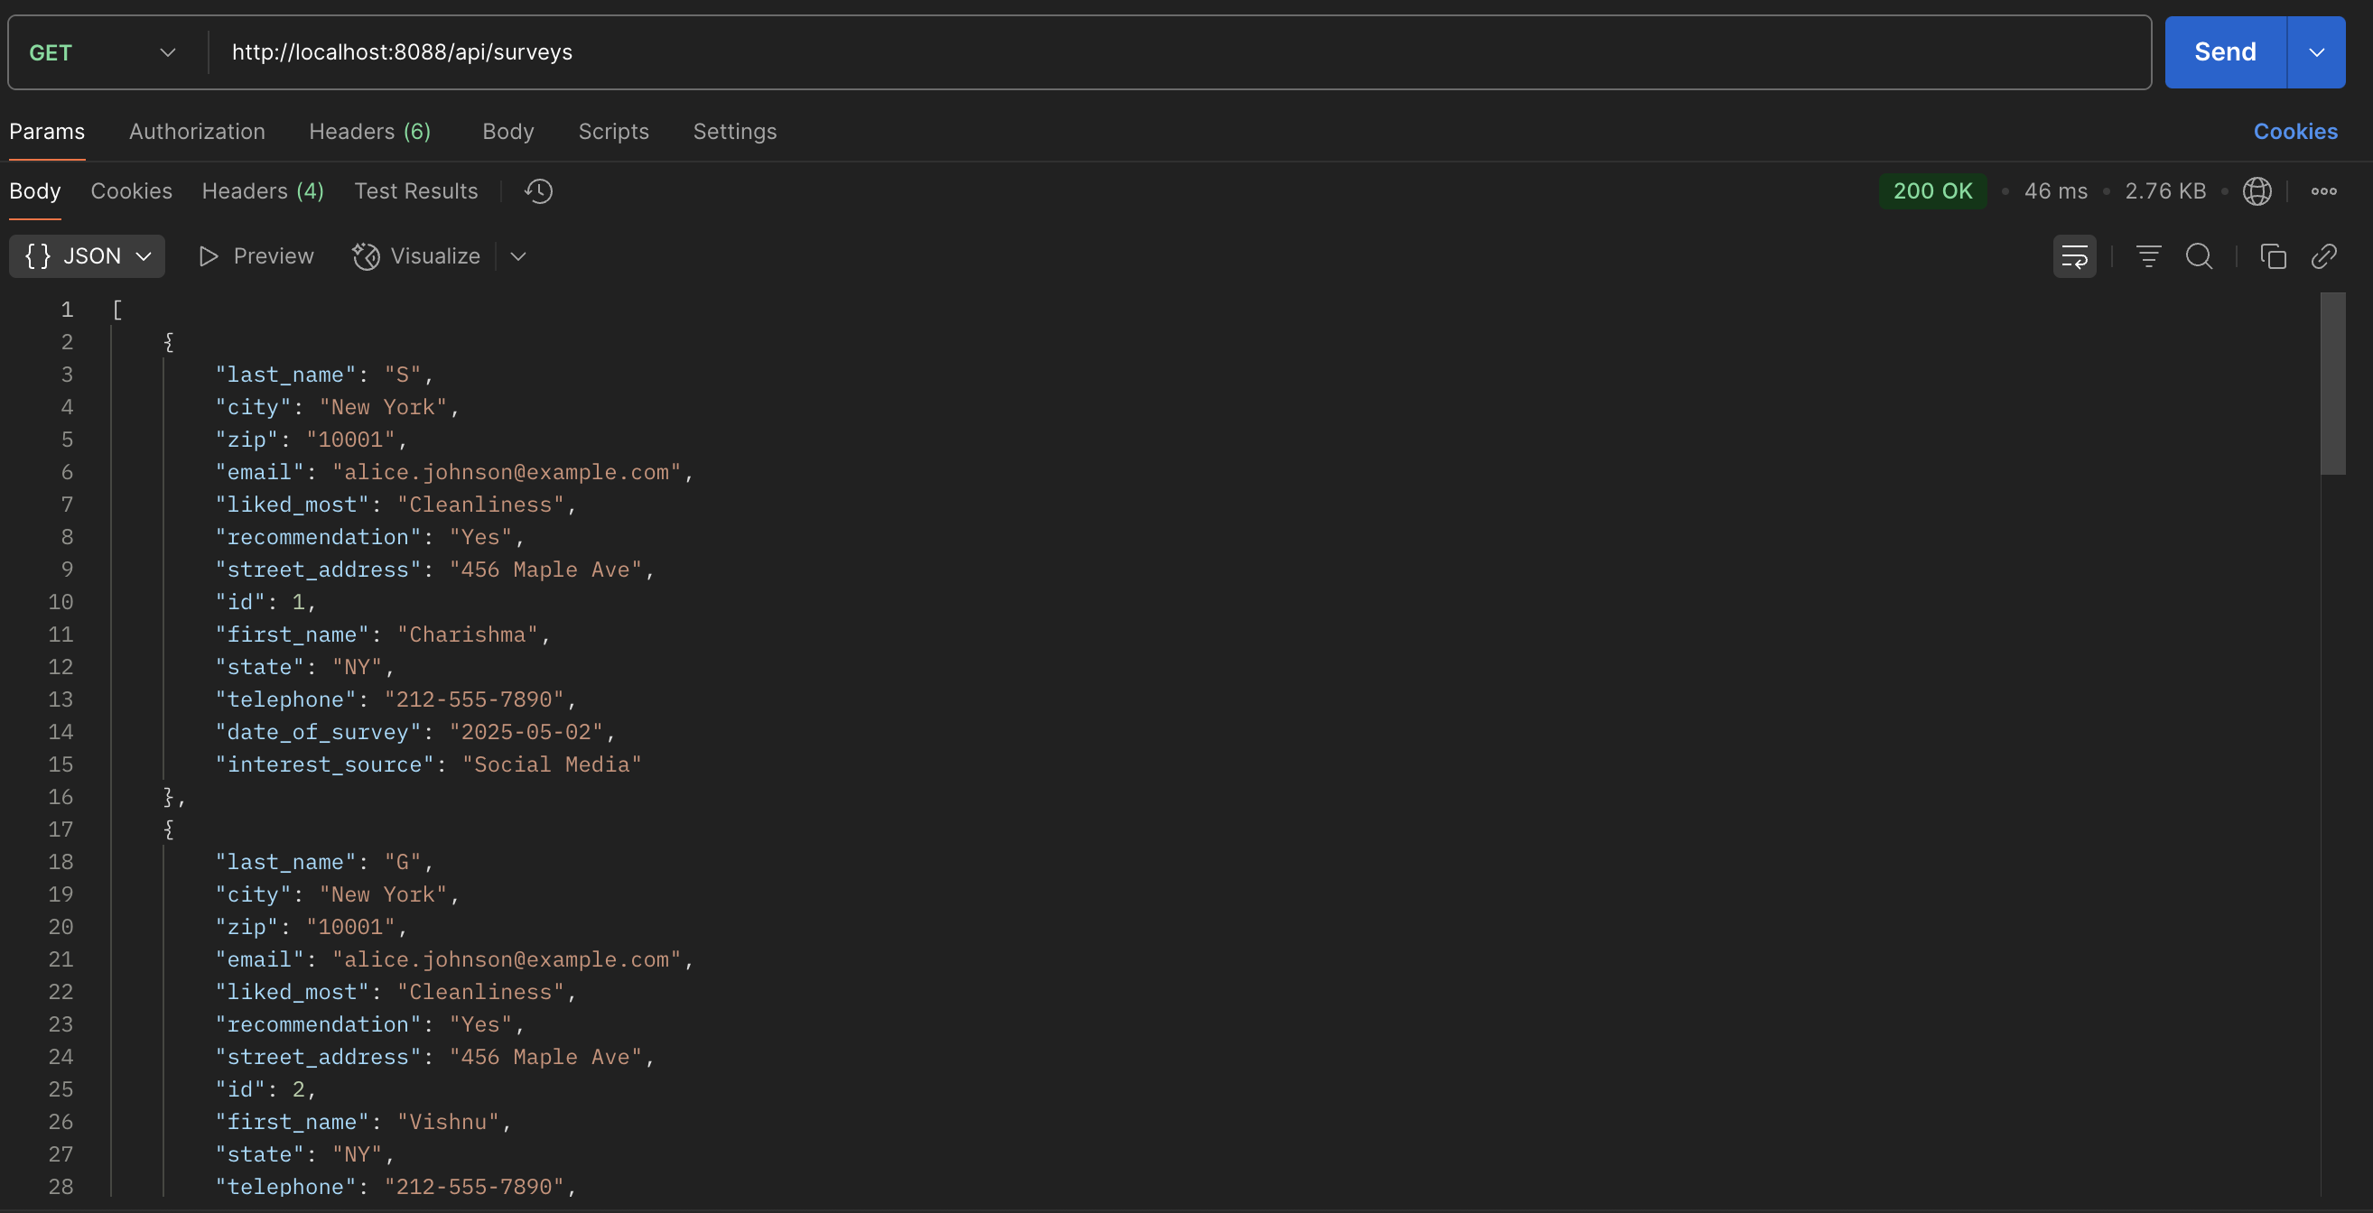

1. **POST**: To create a new survey entry.

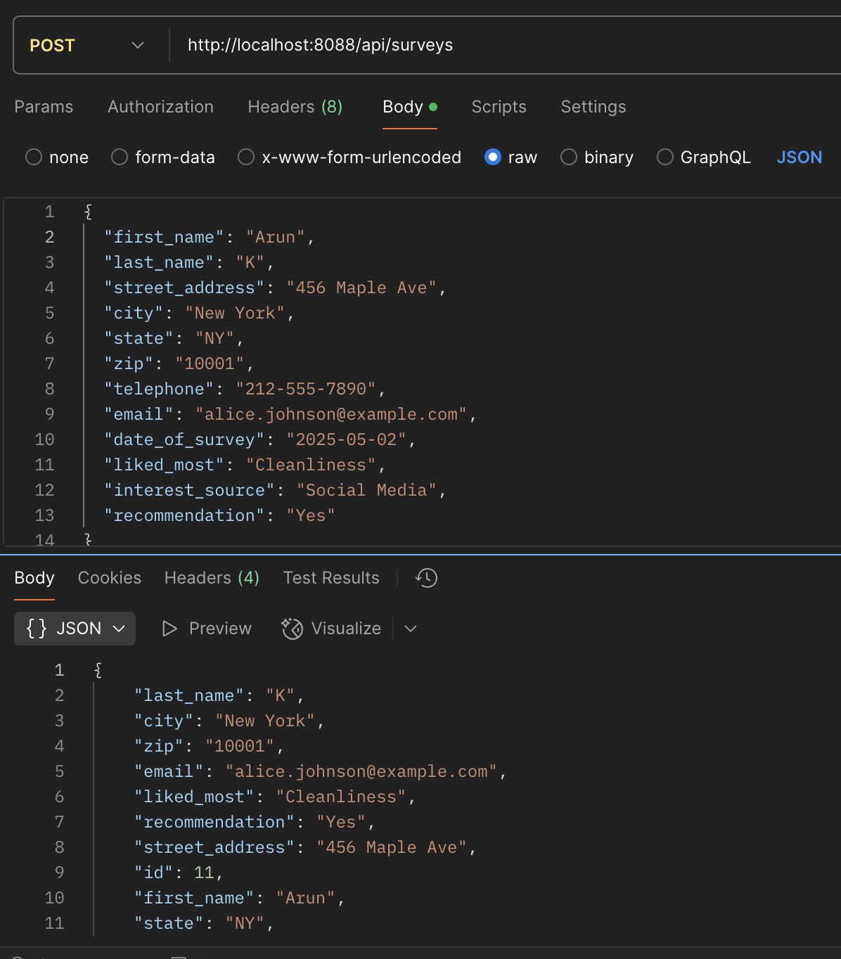

1. **GET BY ID**: To retrieve one record using the ID.

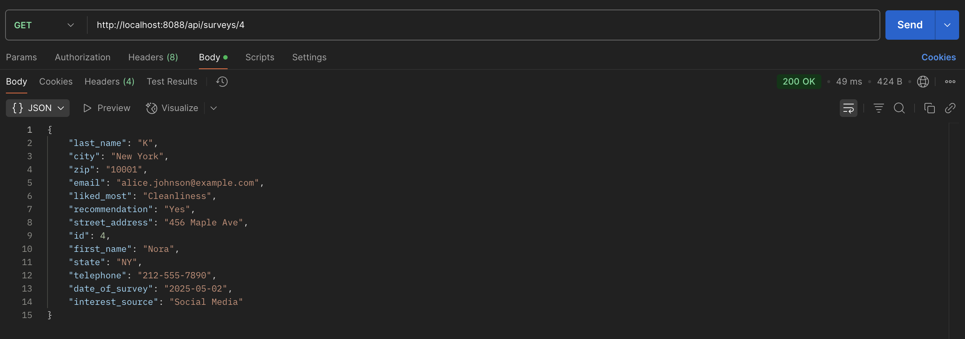

1. **PUT BY ID**: Update any survey record using the ID.

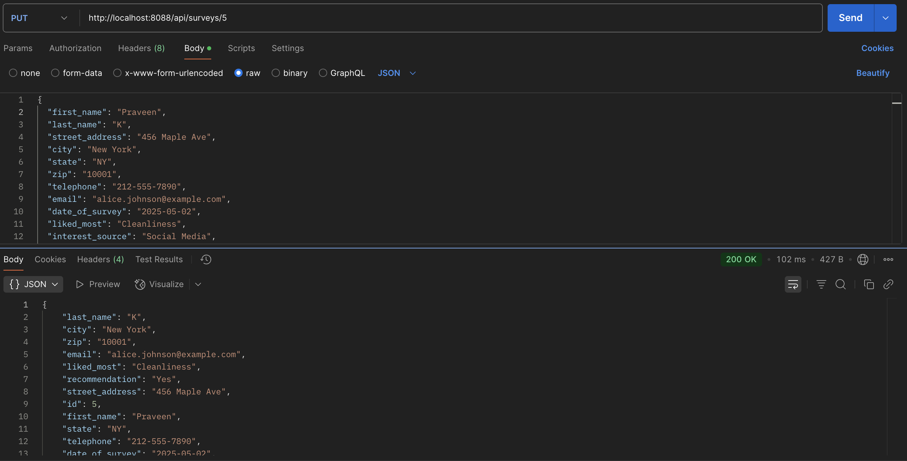

1. **DELETE**: Delete a survey record using the ID. And checking by trying to retrieve that ID.

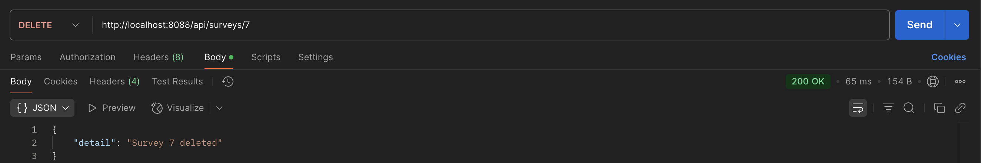

**DEPLOYING OUR DOCKER IMAGE IN KUBERNETES:**

1. We have used **Google Kubernetes Engine (GKE)** to deploy our Docker image in Kubernetes.
2. **Create a Kubernetes Cluster on GKE:** We have first created a project with name **group python** and project id **group-python.** Then created a new cluster with the name student-survey-cluster.

**Command: gcloud container clusters create group-python-cluster \**

**--zone us-central1-a \**

**--num-nodes=2 \**

**--machine-type=e2-standard-2**

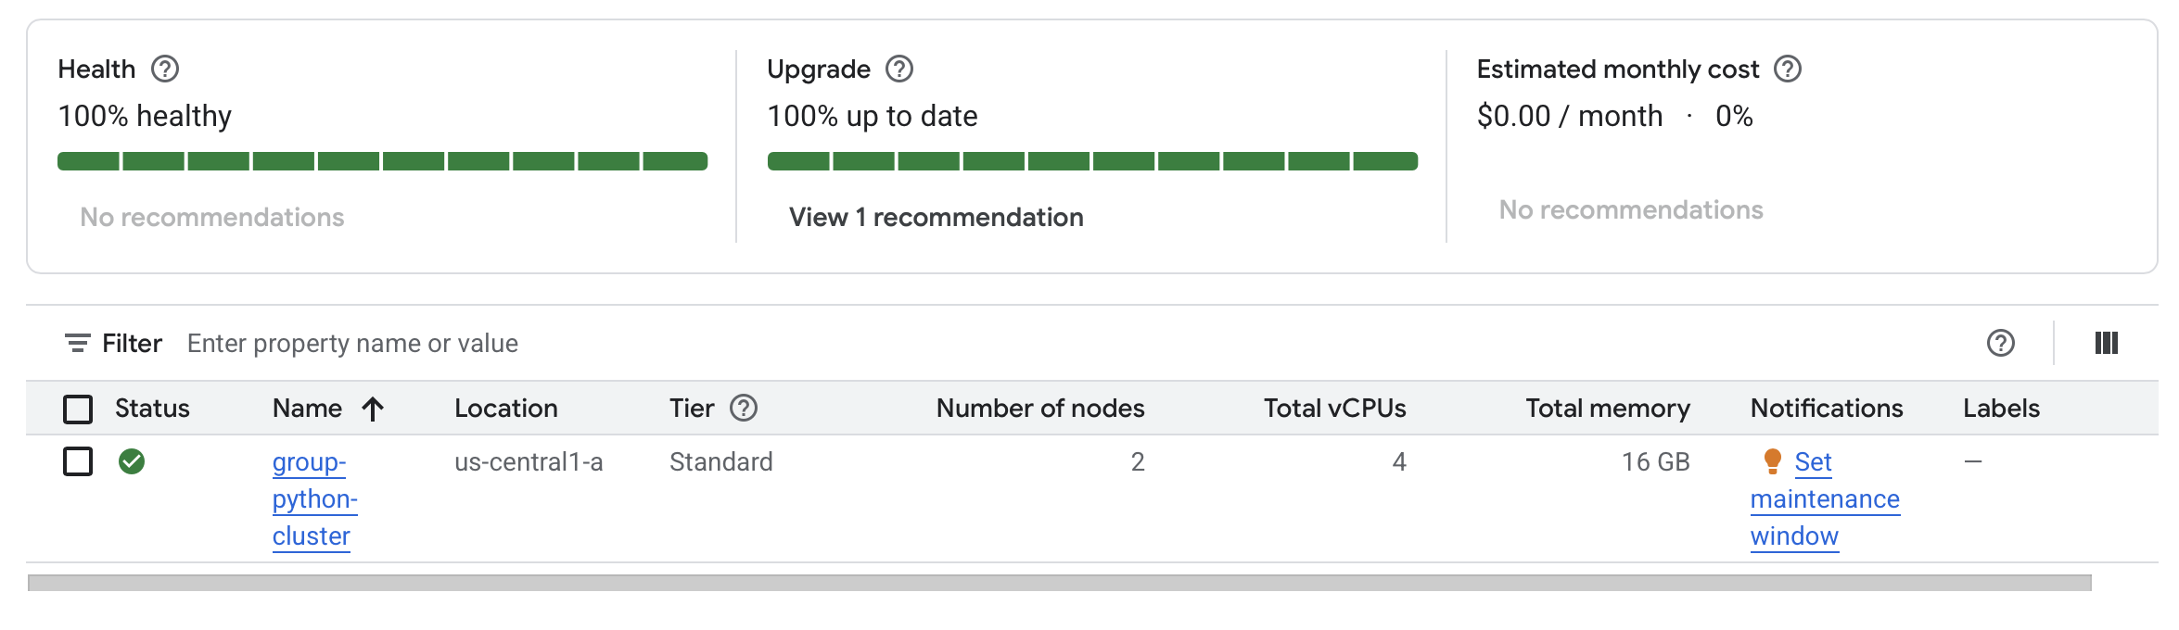

1. **Set project and authenticate docker:** We need to run these commands on terminal to select the project with the help of id and then authenticate docker(this only ensures docker can push images to GCR).

**Set project Command: gcloud config set project group-python**

1. **deploy.yaml and service.yaml:** The deploy.yaml file is a configuration file that tells the cluster what to run and how to expose it using Deployment and Service.
2. **Deploy the Docker Image to Kubernetes:** Now let’s deploy our Docker image on Kubernetes and applying the requirements in deploy.yaml file and also check if our pods are running.

**Command:** **kubectl apply -f deploy.yaml**

**kubectl apply -f service.yaml**

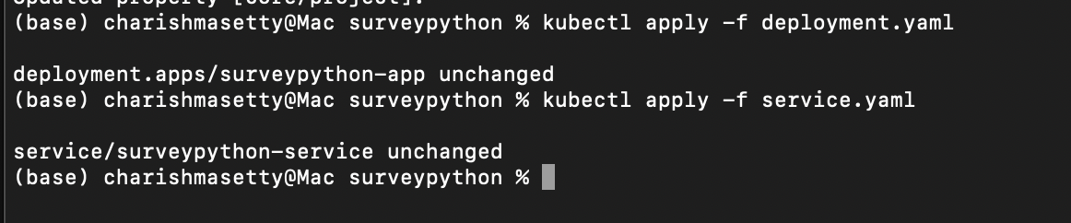

**Pods running command: kubectl get pods**

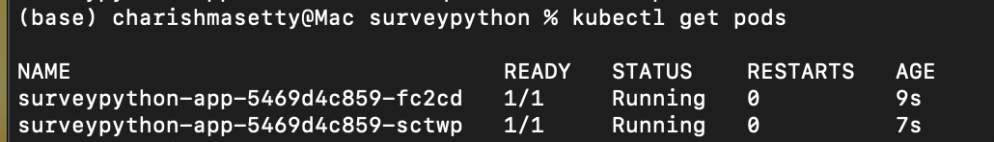

1. **Verify & Access the App in browse:** Retrieve your external Ip using

**Command: kubectl get svc**

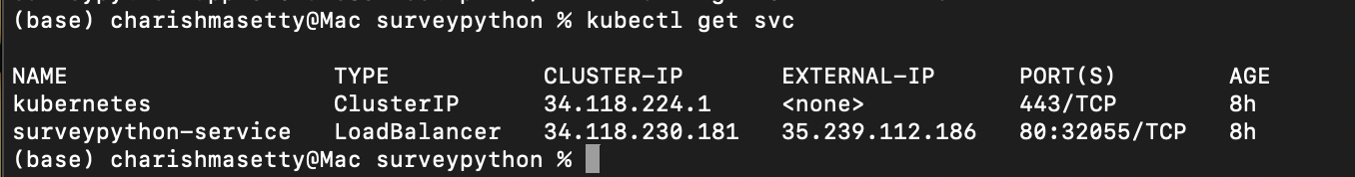

1. The URL to access the project using Kubernetes: <http://35.239.112.186/api/surveys>

**CI/CD PIPELINE:**

1. Establish a CI/CD pipeline that includes a Git source code repository at GitHub, and Jenkins for automated build and for the automated deployment of your application on Kubernetes.

* **Push files onto GitHub:** Push all your files to GitHub using

**Commands: git add .**

**git commit -m “Commit”**

**git push origin main**

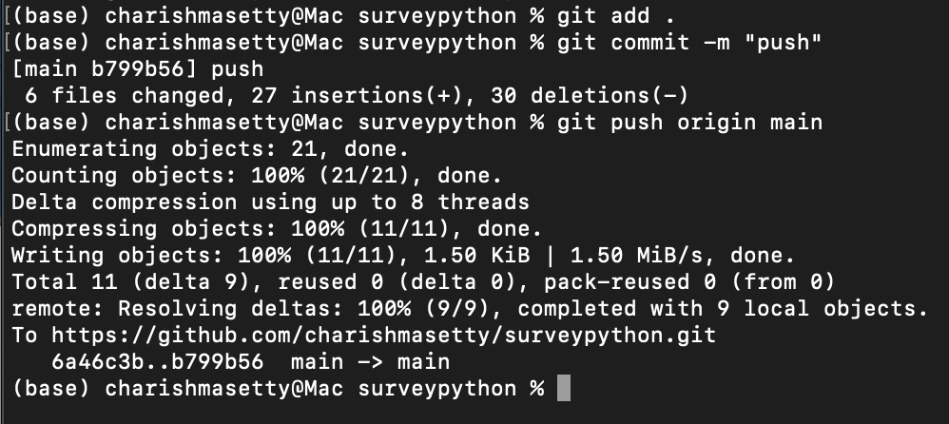

* **Install Jenkins via Homebrew (LTS Version):** We are using homebrew to install Jenkins-lts version.

**Command: brew install jenkins-lts**

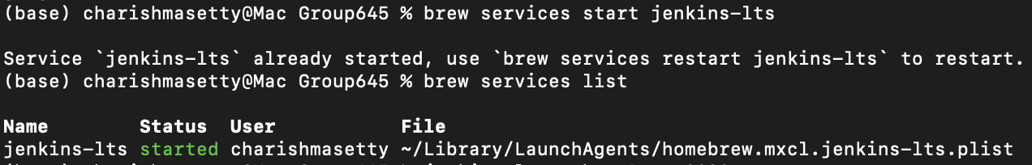

* **Run and open jenkins on a browser:** We will run our jenkins on port 9090.

**Command:** **jenkins-lts --httpPort=9090**

**Link:** [**http://localhost:9090**](http://localhost:9090/)

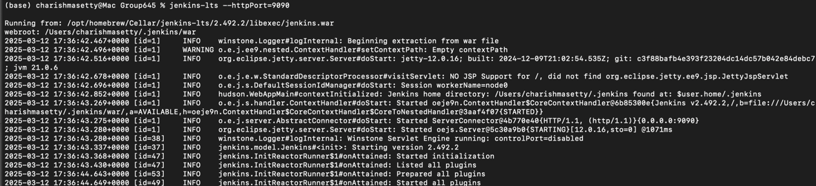

* **Create** the service account google cloud
* **Generate a JSON key** and download it. It will contain the credentials.
* **Add required IAM Roles** to give access to jenkins.

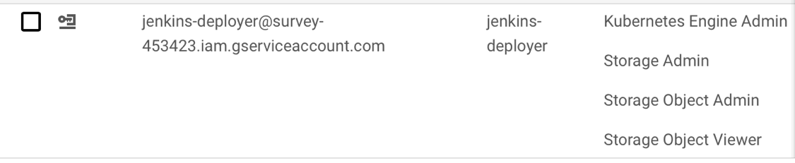

* **Add the Service Account Key we downloaded to Jenkins and git credentials.** In Jenkins → **Manage Jenkins → Manage Credentials**, add a **Secret file** credential:
  + Add the downloaded **group-python-21c7f9811487.json** file. 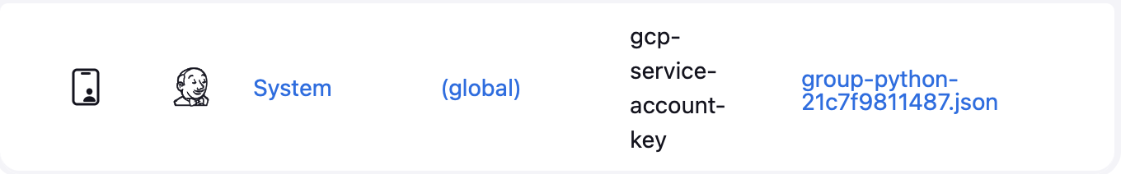
  + Store **GitHub Credentials** similarly if your repo is private.

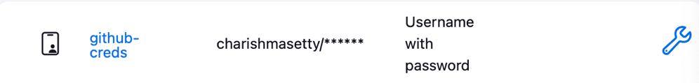

* **Jenkinsfile Setup:** We will create a file which will tell Jenkins to checkout Git repo, Build docker image, Push the docker image to GCR and deploy or update the app on GKE, this should be pushed onto the Git repo.
* **Run the Pipeline: Create a Jenkins Pipeline job** → **Pipeline script from SCM** → point to your Git repo’s Jenkinsfile.

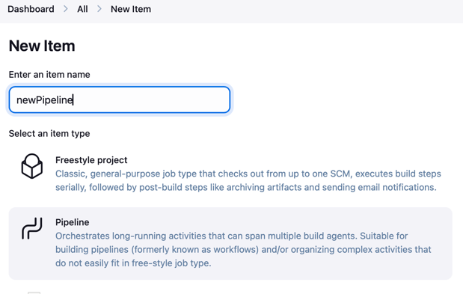

* **Click “Build Now”** in Jenkins or commit changes to trigger the pipeline.

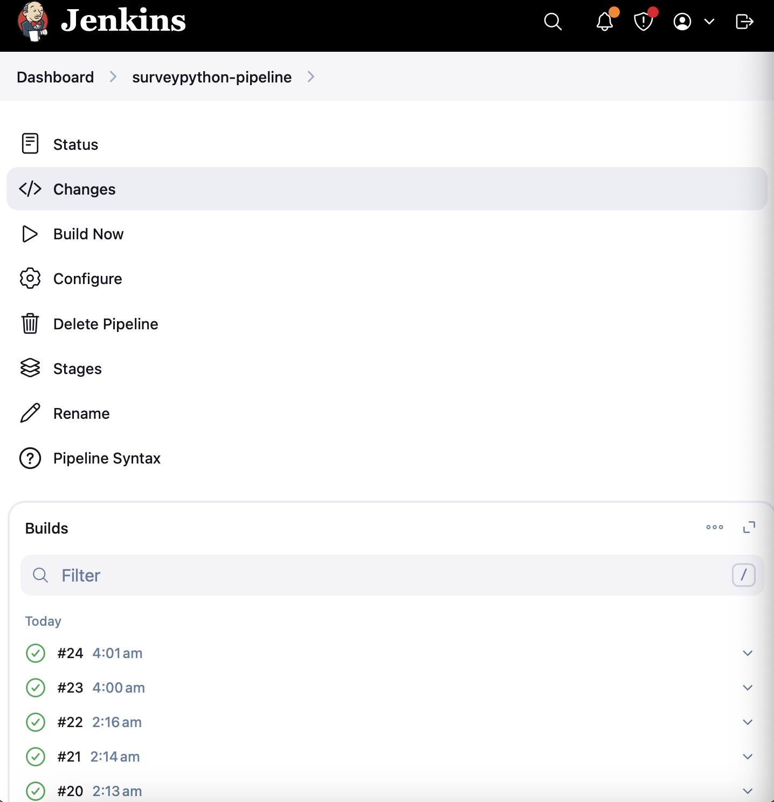

* **If build fails check the console logs** and identify which stage (build, push, deploy) is failing.
* **Check Pods** and service using the following command.

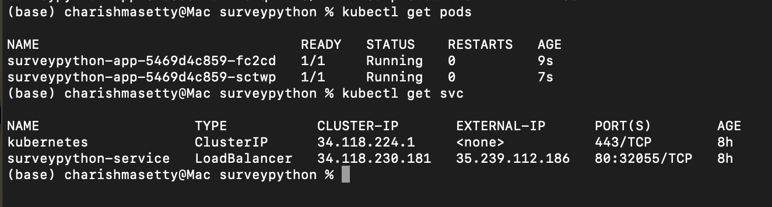

* **Access the External IP**: <http://35.239.112.186/api/surveys>

**VERIFYING CI/CD PIPELINE ON POSTMAN:**

1. **GET**: To get all survey records.

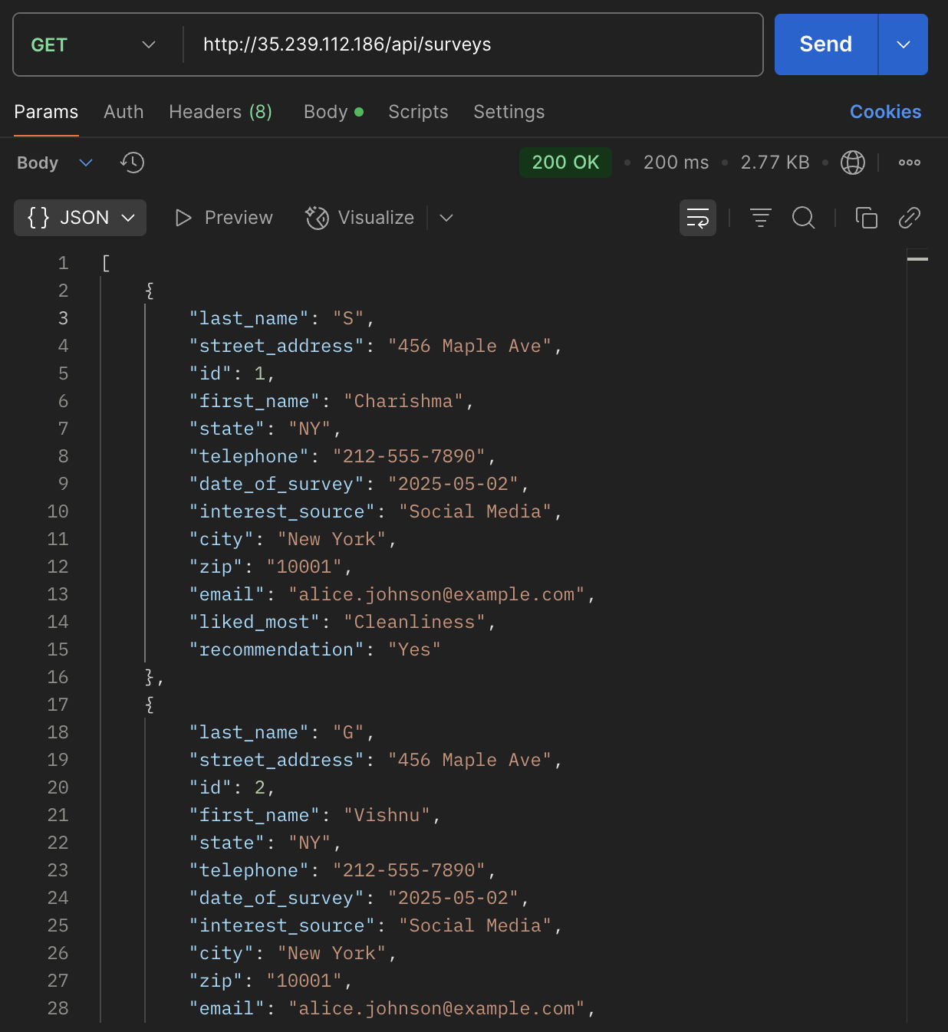

1. **POST**: To create a new survey entry.

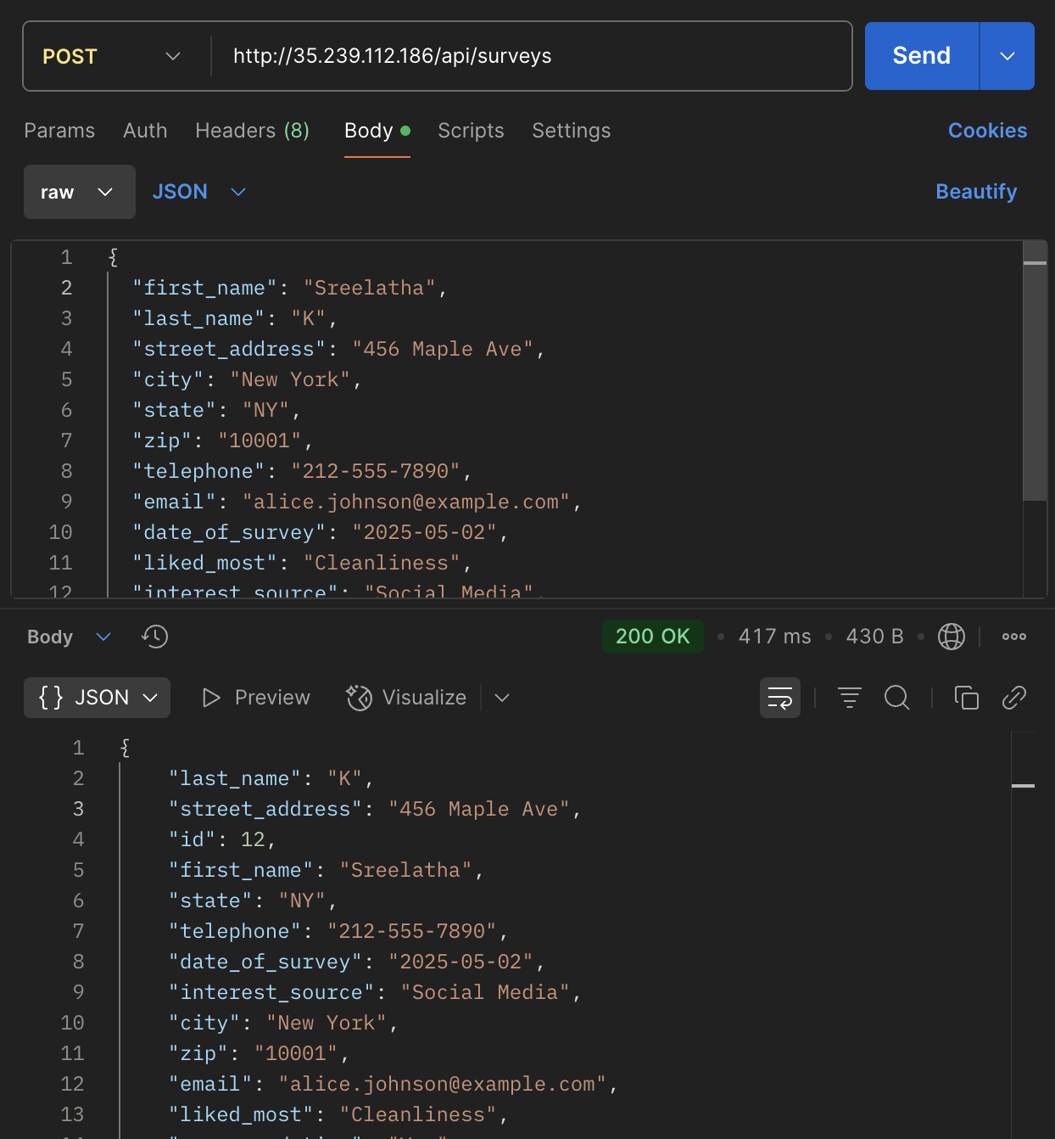

1. **GET BY ID**: To retrieve one record using the ID.

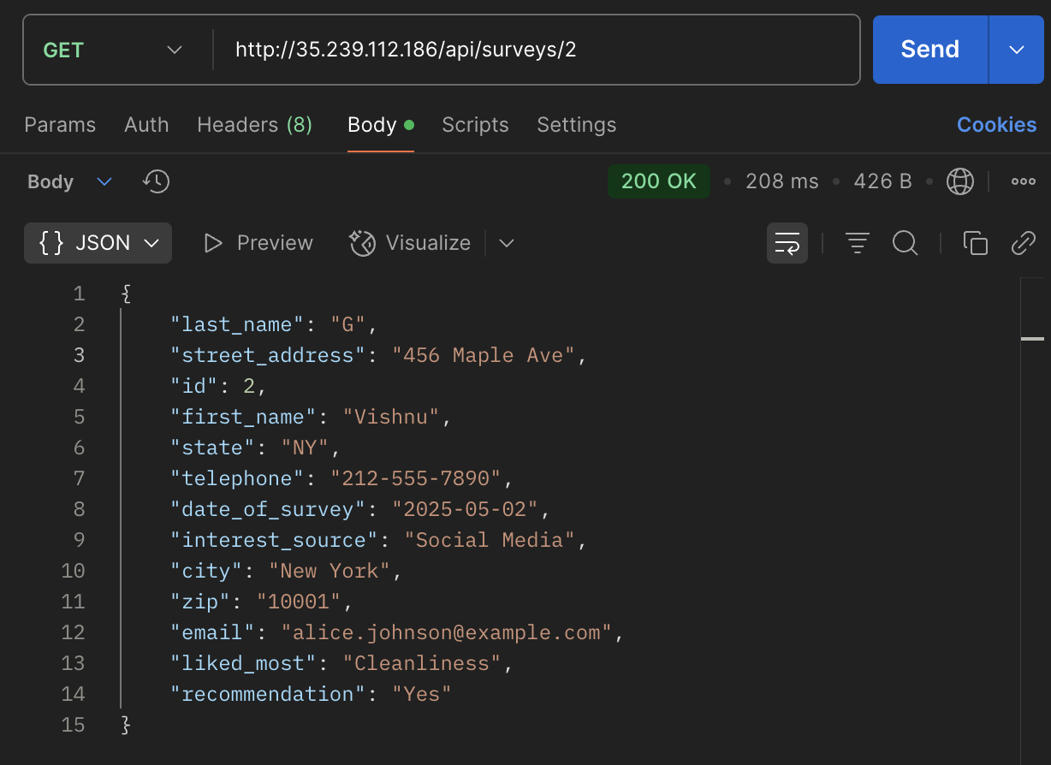

1. **PUT BY ID**: Update any survey record using the ID.

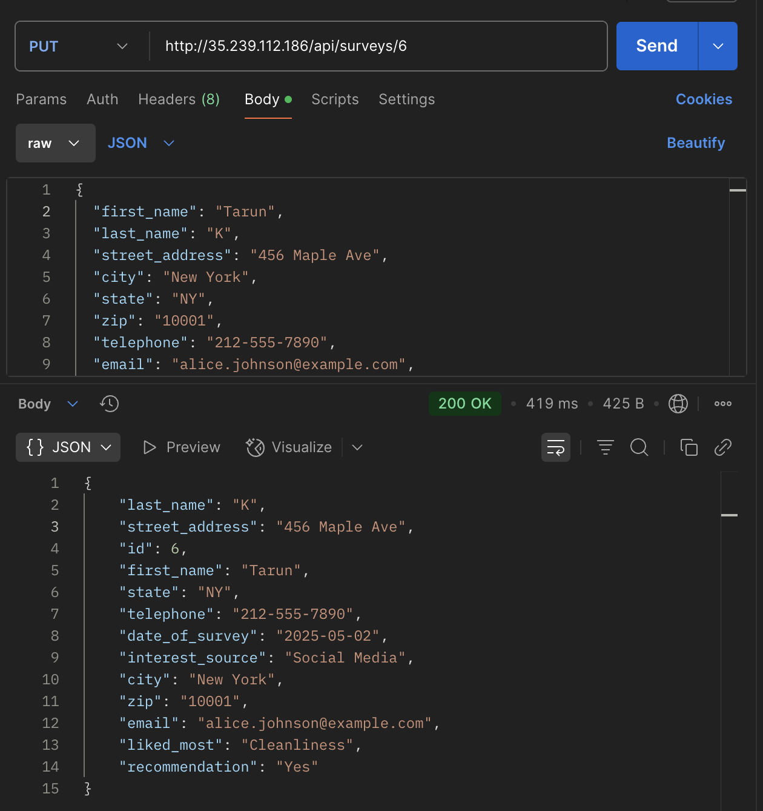

1. **DELETE**: Delete a survey record using the ID. And checking by trying to retrieve that ID.

